Connect the relay32s to USB to TTL ,

About USB to TTL module, you can any version



Pin definition for relay32s



Once connection, it should be like this

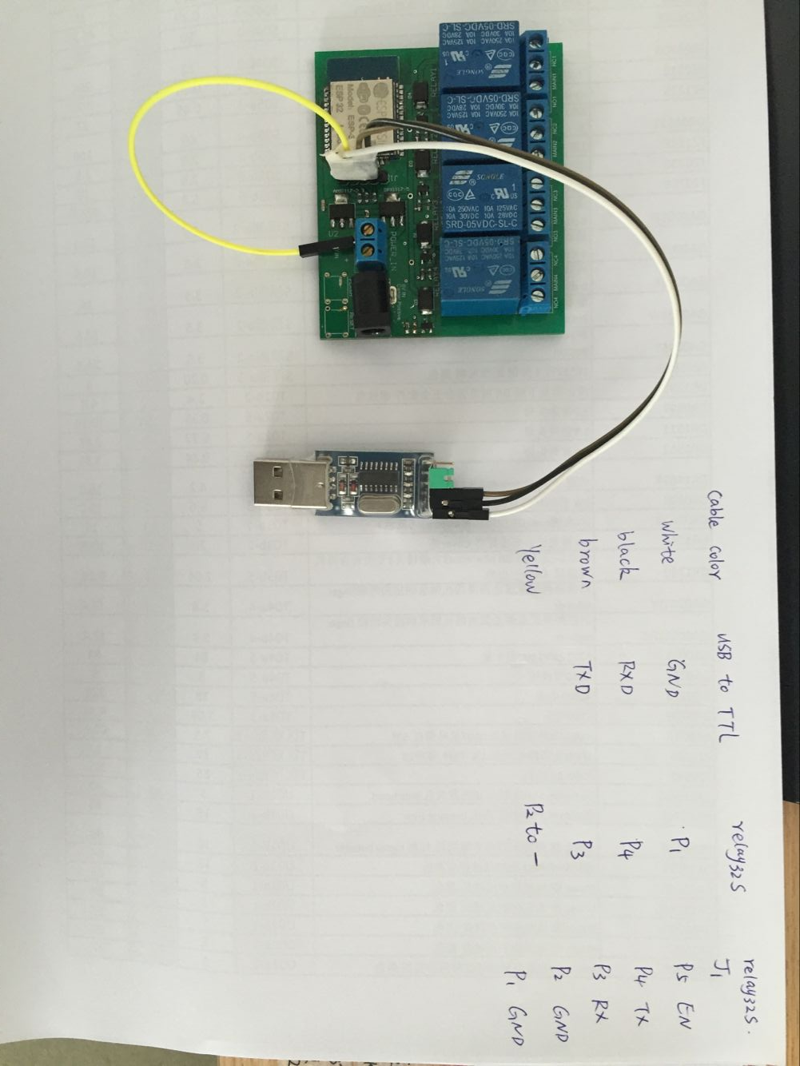

Then you give power to the board , power supply need plug to the socket, usb to ttl connect to the computer usb interface (power supply use 6V 0.6A, you can use adjustable DC power supply too )

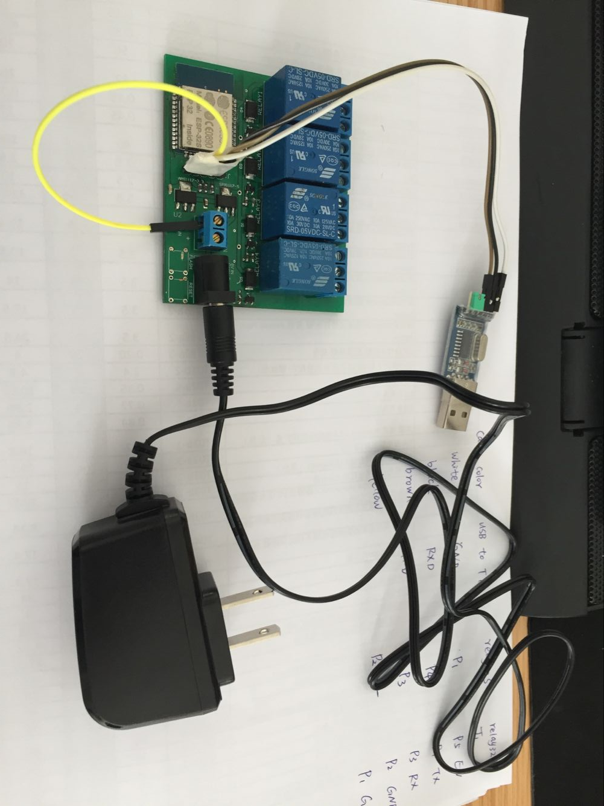

Then please find the process in the document link, the file name is FLASH_DOWNLOAD_TOOLS_V3.4.4, you can find document and process in the file:

